EXERCISE 3:
Create a new branch called gitNewBranch
Git checkout -b gitNewBranch
List all branches
Git branch
Add a new file in this branch
Echo “this is for testing purpose”>testfile.txt
Stage and commit the file
Git add testfile.txt
Git commit -m “adding testfile”
Check branch status
Git status
MERGING
Switch back to master branch
Git checkout master
Check differnces between master and gitNewBranch
Git diff master..gitNewBranch
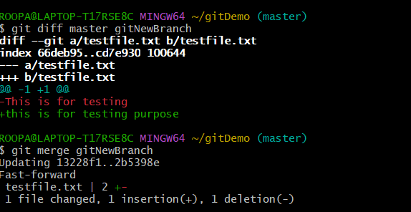
Merge gitNewBranch into master
Git merge gitNewBranch

